**BLOCKATHON 2017 Reasearch Notes**

**External Factors for Effective Blockchain Implementation**

Team: Crystal, Alberto, Sushant, Bill, Mark

**UI Webportal:** [**https://tinyurl.com/blockathon2017**](https://tinyurl.com/blockathon2017)

**Pain Points and Counter:**

The data brokerage industry, buying massive reserves of information from customer-facing companies, is quickly becoming one of the most profitable sectors in the technology industry *Source: Andrejevic (2013). The big data divide. International Journal of Communication, 8.*

So far, the benefits of this big data boom have been completely asymmetric, with the users contributing this information being pacified with the false impression that the services that would already be needed for the collection are somehow a fair financial trade-off.

*Source: Andrejevic (2013). The big data divide. International Journal of Communication, 8.*

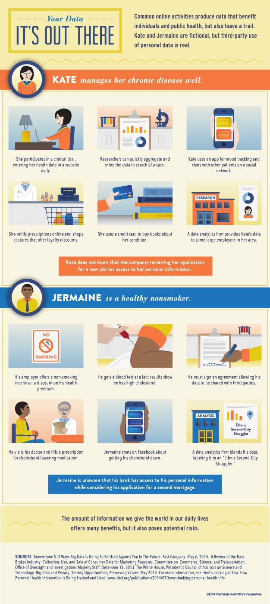

Quantified Self Devices Ratings:

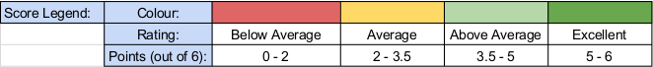

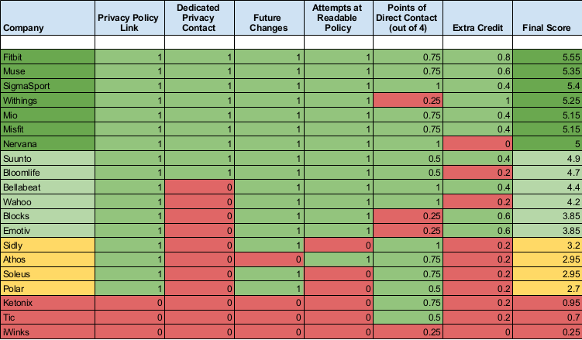

*Source: Human Data Commons: Quantified Self Report Card*

User Platform Ratings:

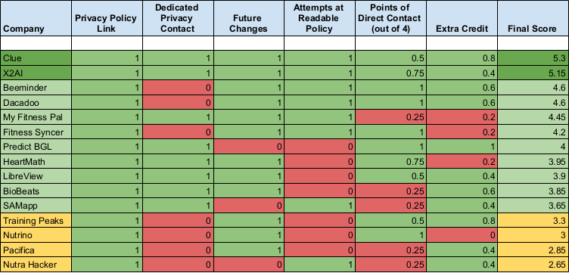

*Source: Human Data Commons: Quantified Self Report Card*

*Source: Human Data Commons: Quantified Self Report Card*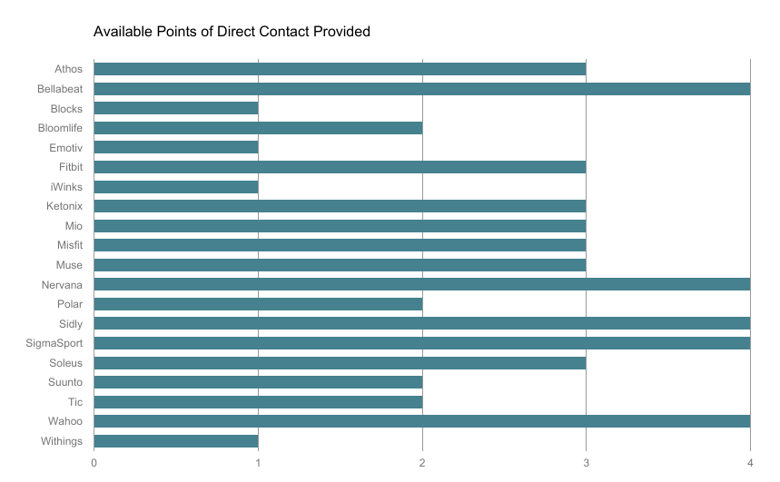

**Direct contact points increase device use!**

The majority of companies in the Devices category provided more than one point of direct contact for general inquiries (email, physical address, phone number, contact form). **This was one of the greatest strengths of the Devices category overall.**

**How to increase trust:**

User trust is a net benefit for such companies: users have shown greater adoption, and longer engagement with, platforms whose practices they trust, according to their self-reports

*Source: Adams, & Sasse (2001). Privacy in multimedia communications: Protecting users, not just data. In: Blandford A., Vanderdonckt J., Gray P. (eds). People and Computers XV—Interaction without Frontiers. Springer, London.*

Additionally, the more a user believes that they have understood the privacy documentation, the more likely they are to trust the company

*Source: Ermakova, Fabian, Baumann, & Krasnova (2014). Privacy policies and users’ trust: Does readability matter? (2014). In: Americas Conference on Information Systems. Savannah, USA.*

Dedicating time to clarifying documentation and user interfaces can improve a company’s bottom line.

*Source: Mehlman (2015). If you give a mouse a cookie, it’s going to ask for your Personally Identifiable Information. Brooklyn Law Review, 81(1).*

Ransomware infiltration in hospitals has increased in the last few years. EHR is one of the most sensitive pieces of information about a person and such data can wreak havoc in their lives if nefarious elements are able to access it. In 2015 alone, there were a total of 112 million healthcare records breached. Blockchain solves the issue with secure storage of this data. Since there is only one source of truth for the data, each node (healthcare provider) in the system derives from it and stores a local copy with it. Each trusted node has a secret private key and a public key that acts as an openly visible identifier. A patient’s private key would be required to access the relevant information from the blockchain. This public/private encryption scheme allows the patients to share unique information with different healthcare providers on as-needed-basis and also look at the access log. Even if a patient’s private key is hacked, the damage is contained and other records still remain secure.

*Source: http://dataconomy.com/2017/03/blockchain-solution-healthcare/*

THE CHALLENGES OF IMPLEMENTING BLOCKCHAINS FOR EHR  
  
First of all is the issue of scalability. Blockchain requires a huge amount of power to operate. At some point the trade-off between transaction volumes and computation power required would become too difficult to sustain and this puts a physical limit on what we can possibly achieve with this technology. Another issue is of data standardization and storage limits. Blockchain is good for storing standardized data fields like age and sex and summary in text form, but not expansive medical details like notes or abstract data types like MRI scans and human genome. This means that such data would require alternative storage anyway. This would require additional integration layers to be built to interoperate with the blockchain system.

*Source: http://dataconomy.com/2017/03/blockchain-solution-healthcare/*

From data rigidity to data sharing

From obscurity to clarity

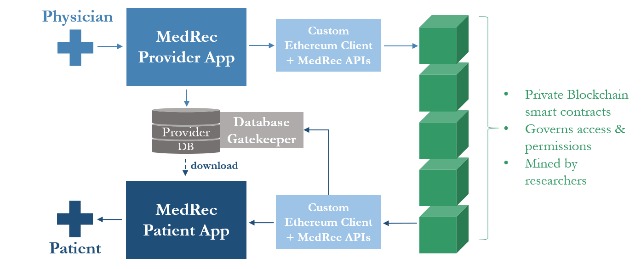

*Source:* [*https://www.pubpub.org/pub/medrec*](https://www.pubpub.org/pub/medrec)

**Alternate Models of Implementation**

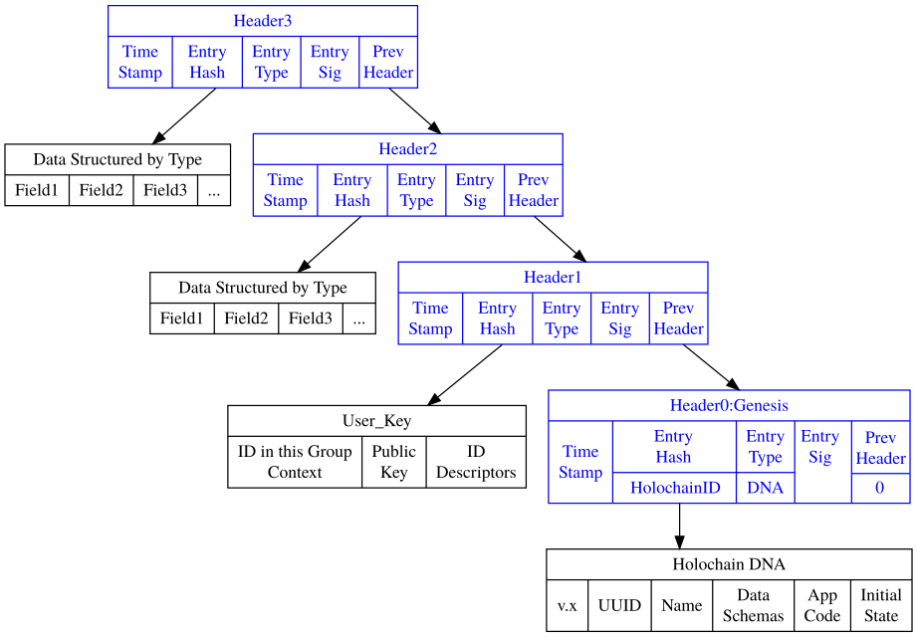

*Source:* [*http://ceptr.org/projects/holochain#summary-of-holochain-architecture*](http://ceptr.org/projects/holochain#summary-of-holochain-architecture)

[*https://github.com/metacurrency/holochain/wiki/Architecture*](https://github.com/metacurrency/holochain/wiki/Architecture)

We describe a holographic data storage architecture which combines the data integrity assurance of Hash-Chains with the efficiency of Distributed Hash Tables while eliminating consensus bottlenecks typical of Blockchain and typical approaches to distributed computing.

[*http://ceptr.org/whitepapers/holochain*](http://ceptr.org/whitepapers/holochain)

**Beyond Blockchain Bottlenecks**

Instead of being built on top of cryptographic tokens they are organized around cryptographic validation of people (peers) validated against an immutable cryptographic record of those peers actions.

This change allows us to manage data integrity without the massive overhead of computing consensus on a global ledger. Our monotonic, validating, graph DHT (distributed hash table) achieves eventual consistency while only allowing valid data to propagate and holding everyone accountable for their actions.

Unlike a distributed database, there are no methods for users to directly interact with the data because this would bypass application specific validation rules. All interactions happen only through the application code which enforce whatever business rules, application logic, or restrictions they need to, since different applications have different demands for strictness.